Introduction
My favorite way of installing python is to use the anaconda.org miniconda distribution. The full anaconda distribution is huge; minconda is a minimal version. After it is installed you install just the modules you need. Go to the miniconda downloads page and download the latest version for your laptop. Do the usual to install the program.
You have to run the python manager conda from a terminal. To start a terminal window:
- In Windows, a terminal window is called command. Press the Windows key and type command, then click on Command.
- On a Mac, press <command>+<space> and type terminal and click on Terminal.app. If a window does not show up, press <command>+N.
In the terminal window at the prompt type conda update --all. Answer yes to do the update.

Add Modules
There are several python modules we will use. To install these type
conda install numpy matplotlib scipy jupyter. Again answer yes to install them.
Test the modules by typing jupyter-notebook in the terminal window. A browser window should show up with the start page for jupyter notebooks. You are ready to go!
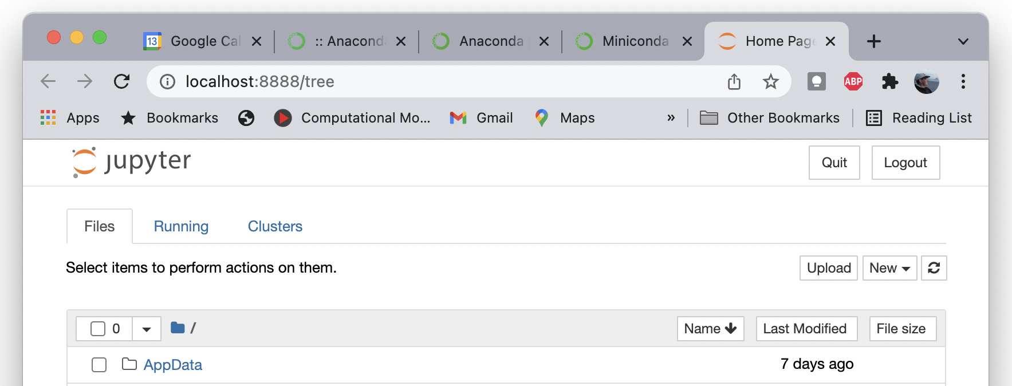Figure 1: The jupyter notebook starting page.

Stopping
Close your open notebooks by clicking File – Save and Checkpoint, then File – Close and Halt.

Starting Jupyter-Notebook
Start a terminal. In the window type jupyter-notebook, and it should pop a browser window.

